SQL QUERIES

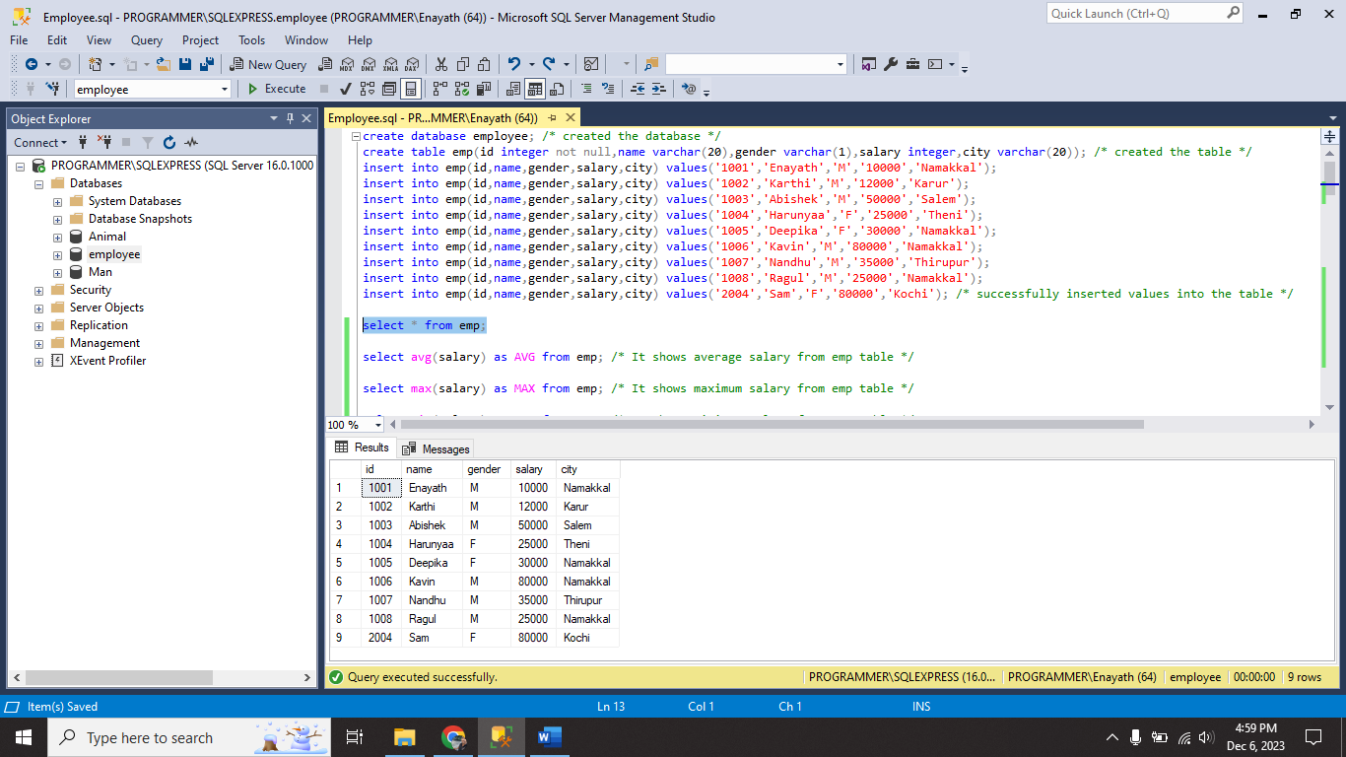

I created the table **emp** and successfully inserted values into table.

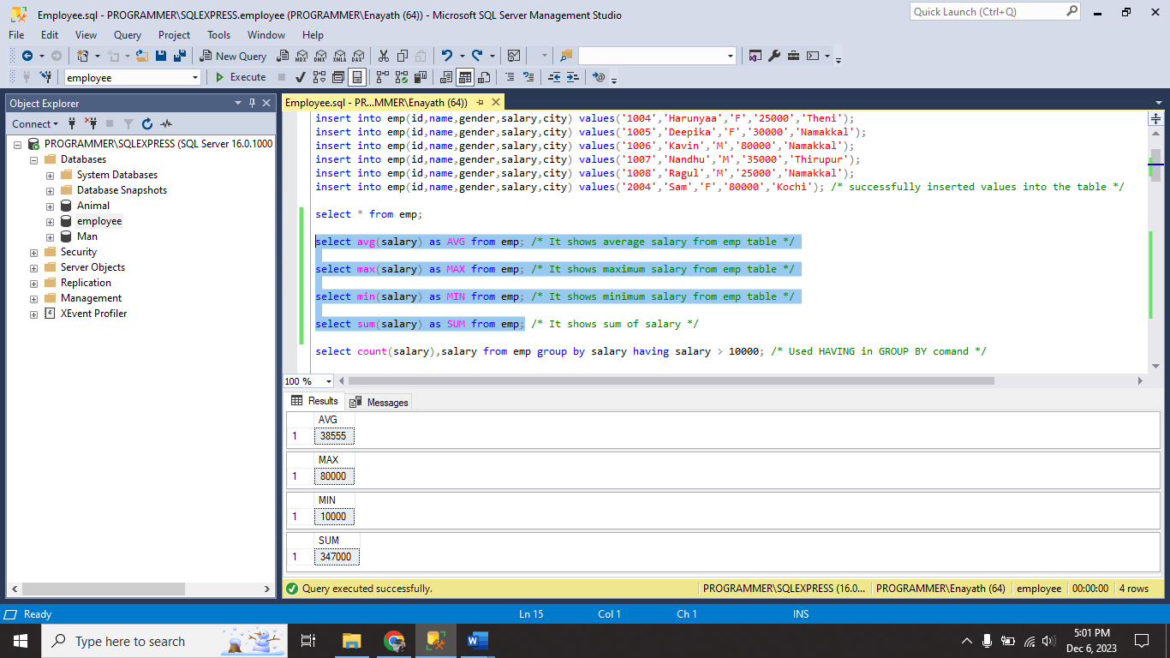

I used all aggregate functions **AVG,MIN,MAX,COUNT,SUM,DISTINCT.**

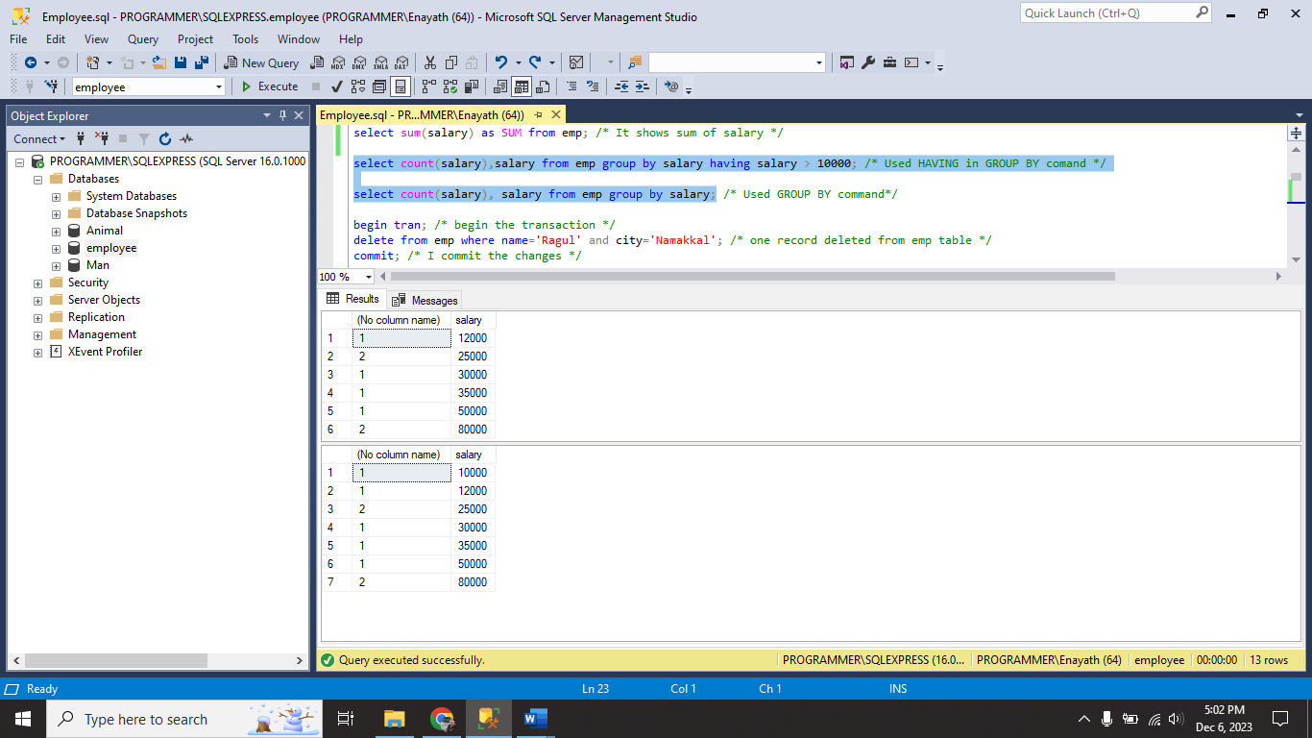

I used both **GROUP BY** and **HAVING** functions.

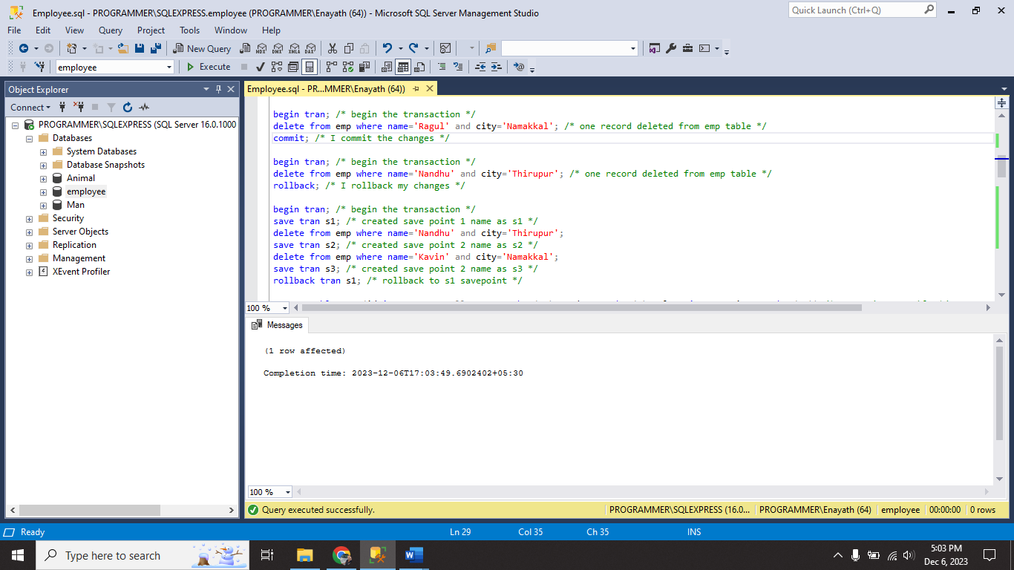

I begin the transaction and performs **COMMIT, ROLLBACK** and **SAVE POINT.**

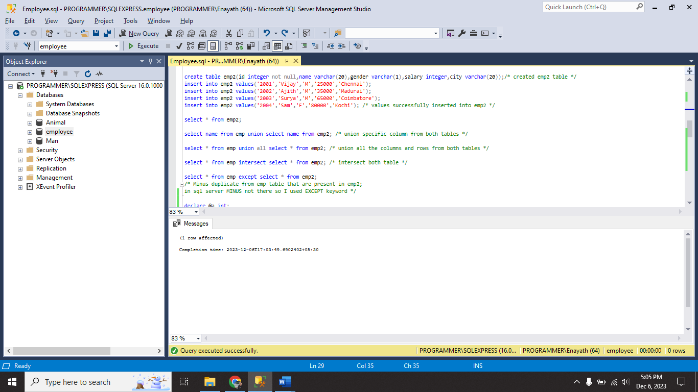

I created **emp2** table and perform **UNION, UNION ALL, INTERSECT** and **EXCEPT (MINUS).**

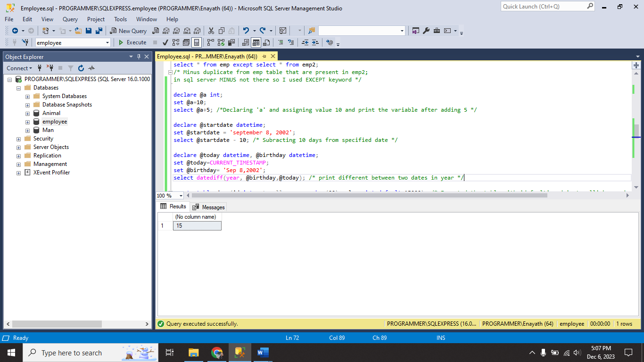

I declare variables and perform addition, subtraction on them and also, I used DATETIME datatype for adding date and also finding different between two dates.

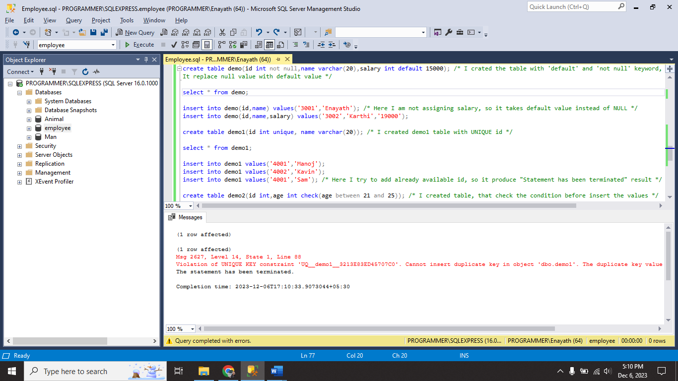

I created tables **demo, demo1** and in demo table I using **DEFAULT** type for salary. In demo1 table I using **UNIQUE** type for id.

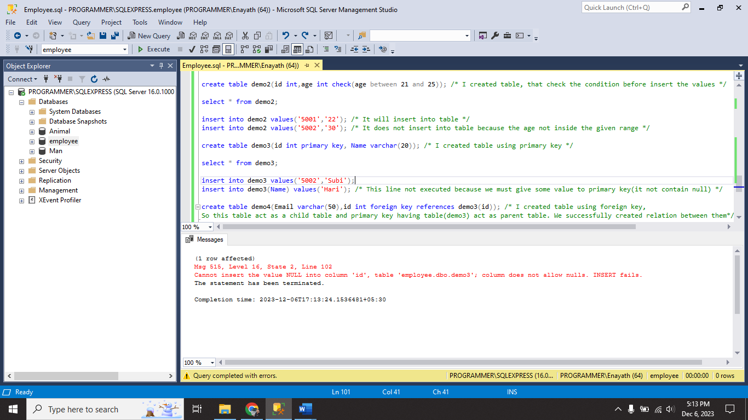

I created tables **demo2, demo3** and in demo2 table I using **CHECK** function. In demo3 I using **PRIMARY KEY** for id.

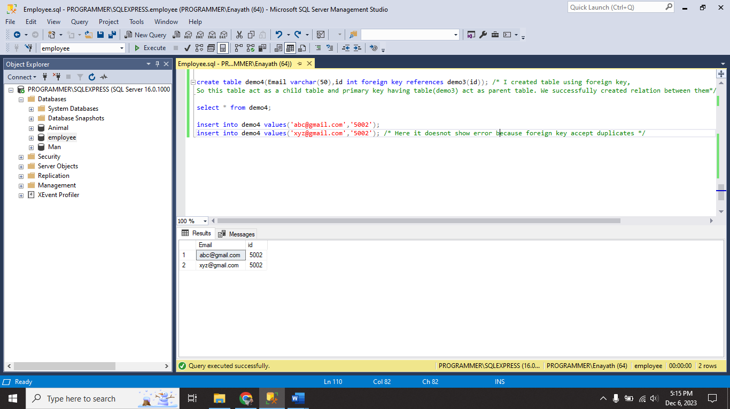

I create **demo4** table using **FOREIGN KEY** combine with demo3 table’s primary key.

|  |  |
| --- | --- |
| AVG | Returns average value |
| MIN | Returns minimum value |
| MAX | Returns maximum value |
| COUNT | Returns count value |
| SUM | Returns sum value |
| DISTINCT | Returns distinct or unique value |
| GROUP BY | It used for group the values based on some attributes |
| HAVING | It is condition statement we are using instead of where |
| COMMIT | It commits the changes permanently in database |
| ROLLBACK | It undo the last performed operation |
| SAVEPOINT | It used for save stages of performed queries. Same as commit but not permanently save in database. |
| UNION | It combine both tables column only. |
| UNION ALL | It combines both tables column and rows also |
| INTERSECT | It produce common attributes present in both tables. |
| EXCEPT | It produce not common value that are presented in first table. |
| DECLARE | Used to declare a variable |
| SET | Used to set value for variable |
| DATEDIFF() | Used for finding different between two dates. |
| DEFAULT | It replace NULL values with default values. |
| CHECK | It check the condition before insert into the table. |
| PRIMARY KEY | It must be unique and does not allow NULL value. |
| COMPOSITE KEY or CANDIDATE KEY | It is combination of two primary key.  Ex: create table demo6(id int,name varchar(50),primary key(id,name)) |
| FOREIGN KEY | It used for combining another tables primary key with another table.  The foreign key table act as child table and primary key table act as parent table.  It allows duplicate values and also NULL values |